|  |
| --- |
| **Vector the Navigator** |
| Microprocessor project proposal  **Infinity Dream team:**  **Mohamed Mayla Eslam Hashem Ahmed Alzoghby Abdelrahman Sharabasy** |
|  |

4/4/2013

# Description

Vector is a 4-wheel robot that has the ability to navigate, detect and draw all obstacles around it.

Vector will be controlled via computer program that has an easy interface and usability.

The communication between the computer and vector will done wirelessly.

Computer

Vector

Wireless M1

Wireless M2

# Functionalities

Vector has 2 modes of operation

## Mode 1:

The live feedback mode (Radar mode),

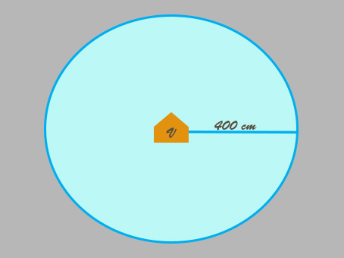This mode let you to control Vector manually with live view to all obstacles around it.

Vector in this mode always refresh the view around it, with a circle with radius 400 cm

## Mode 2:

The navigate and draw mode (map mode)

In this mode we will control Vector also manually but vector always save the entire environment around the path we driven along it (radius 400 cm).

If we drive Vector like this

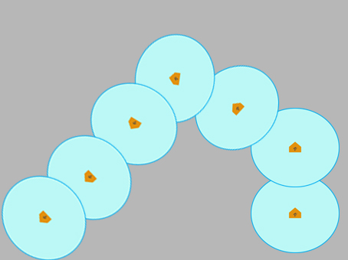

While drive Vector and moving, you will see that, you are generating a map for your path

So after finishing your path you will have a map to your path with all obstacles you were faced.

This mode is so useful when trying to navigate unknown place or unreached places like small places, and want to have a map to the path with all obstacles around it.

# Device used

|  |  |
| --- | --- |
| Device # | Device Name |
| 1 | Arduino UNO microcontroller |
| 2 | Stepper motor |
| 3 | Servo mottor |
| 4 | Ultrasonic |
| 5 | RF wireless module |

# Vector Design

RF wireless module

Ultrasonic

Ultrasonic

Servo motor

Arduino UNO

Stepper motor

Stepper motor

# Project Timeline

|  |  |
| --- | --- |
| Date | Milestone |
| SAT 6/4 | * Car design * Control the stepper via controller (the robot can walk) |
| SAT 13/4 | * Wireless controlling (parallel interfacing) * Finish the car design (servo stand) * Integrate all other robot component (servo - ultrasonic) |
| SAT 20/4 | * The PC interfacing program * Initialize the 2 modes of operation for the robot |
| SAT 27/4 | Final testing  And  Ready to deliver |
| SAT 4/5 | Delivery |